Karthick VM
Batch-CIS 1.3
Mock Assessment 1 – Python

PROGRAM 3:
File Handling Utility – Text Analyzer Objective:
Read sample .txt file and display all Unique cities
sample.txt ( copy the below to sample.txt file )
EmpID,Name,Department,Location
E1001,Asha Rao,Data Science,Mumbai
E1002,Rahul Mehta,IT Support,Hyderabad
E1003,Neha Singh,Human Resources,Hyderabad
E1004,Vikram Das,Finance,Mumbai
E1005,Priya Kapoor,Marketing,Hyderabad
Requirements:
- Ask the user for a file path; open safely with try/except for FileNotFoundError.
- Use if condition whereever required
- Use user defined function

- Creating file named “sample.txt” with given data
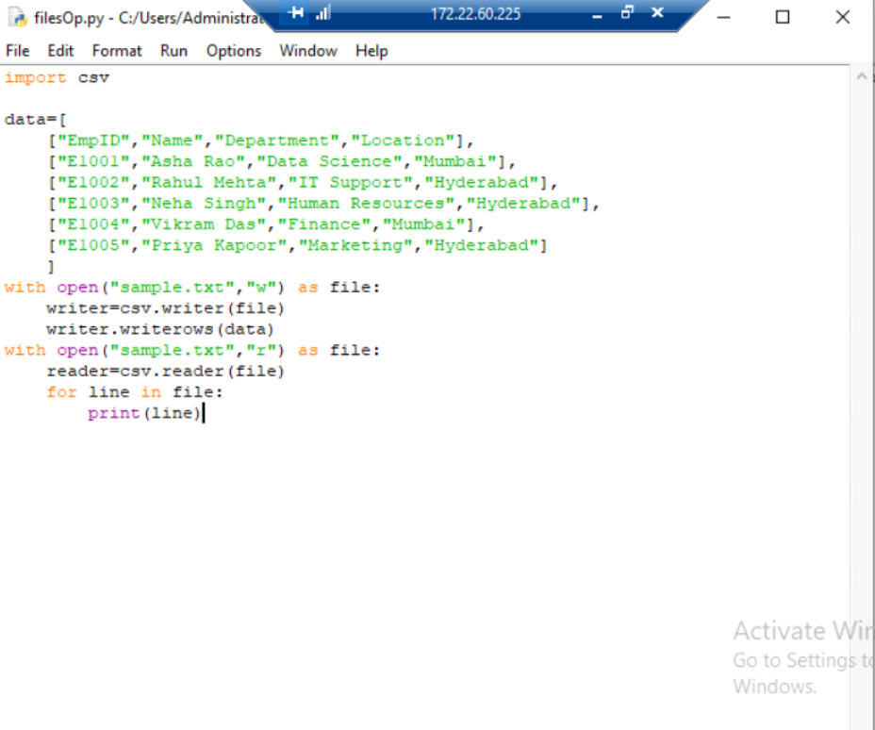
- Display the file

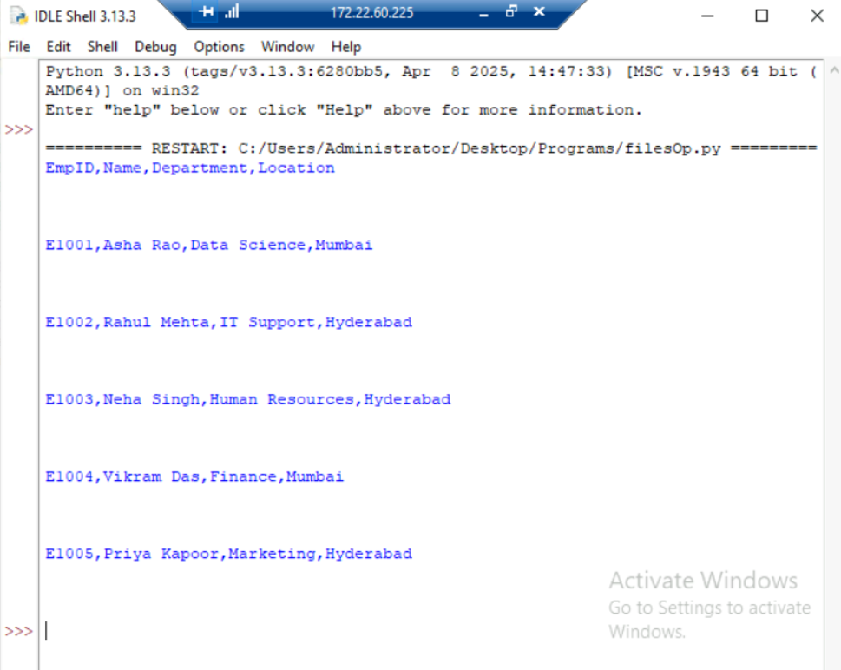

- Program to check if file exists and display the list of unique city names – using try,except,set functions
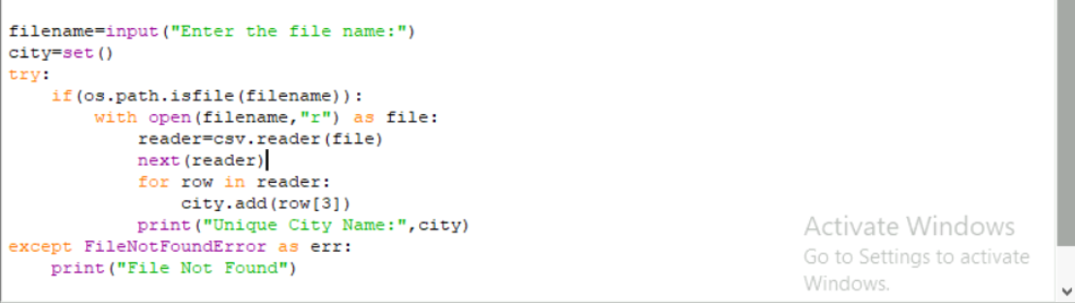
Sample Input/Output:
Sample Input: Enter path to a .txt file: sample.txt
Sample Output: < all unique city names line by line >
- Output for the above program
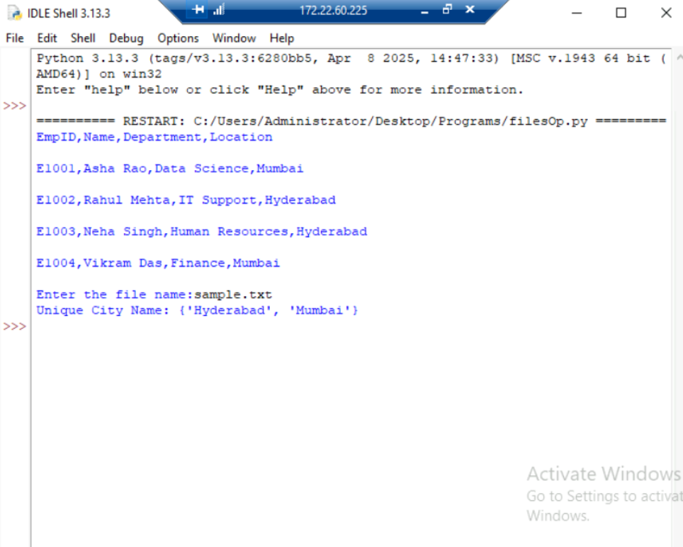

PROGRAM 4: :
List Methods — Clean & Normalize Shopping List Objective:
Use only list methods (append, extend, insert, remove, pop, index, count, sort, reverse, slicing). Requirements:
- Input: a raw list like [" Milk", "eggs", "MILK ", "bread", "Eggs", " butter "].
- Trim whitespace, convert to lowercase, and remove duplicates while preserving order (no set).
- Print final sorted list and also reversed order.
Sample Input/Output:
Sample Input: [" Milk", "eggs", "MILK ", "bread", "Eggs", " butter "]
Sample Output: Counts: milk: 2, eggs: 2, bread: 1, butter: 1
Clean list (sorted): ['bread', 'butter', 'eggs', 'milk']
Reversed: ['milk', 'eggs', 'butter', 'bread']

- Creating and displaying the list
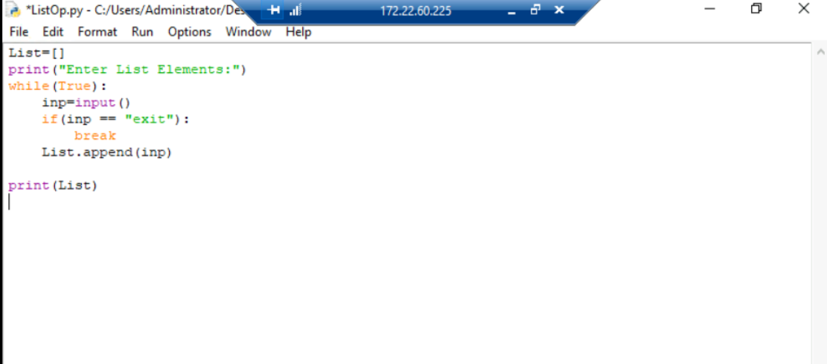

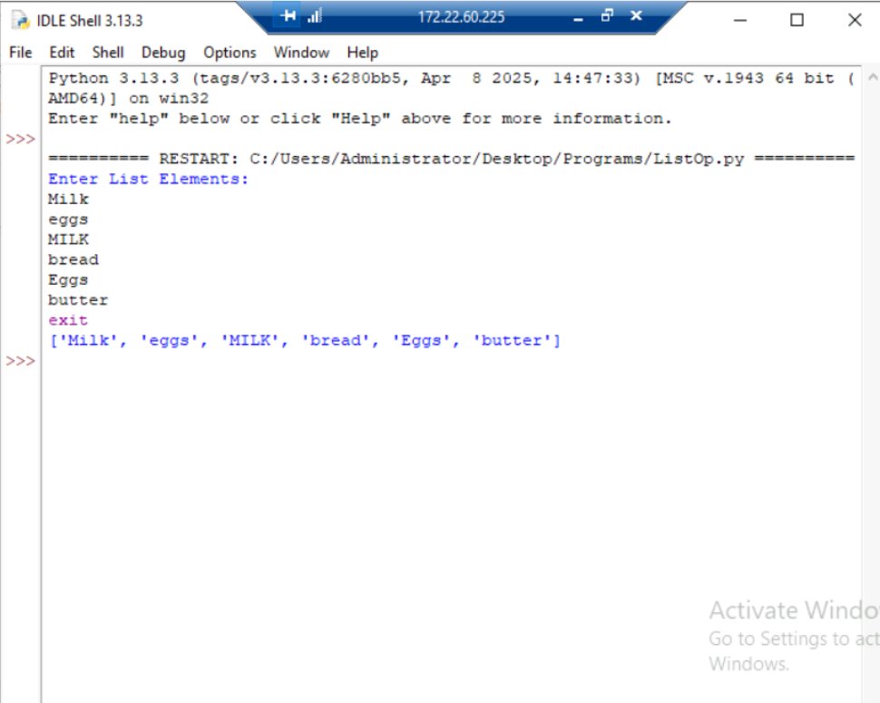

- Creating the Cleaned list with given specification i.e lowercase
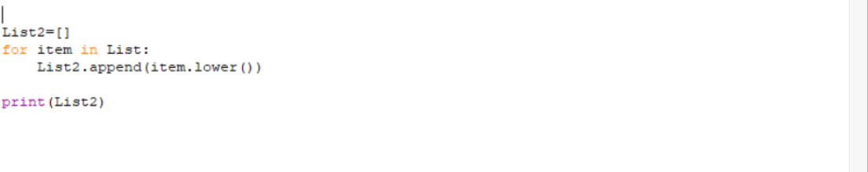

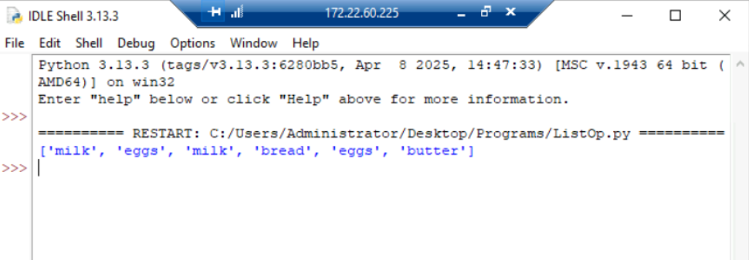

- Program to get count of items present in the list

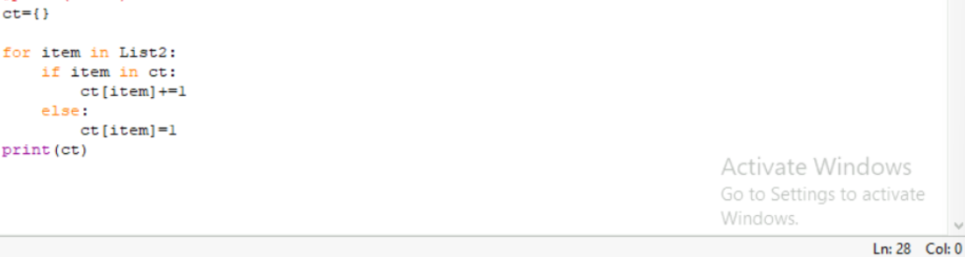

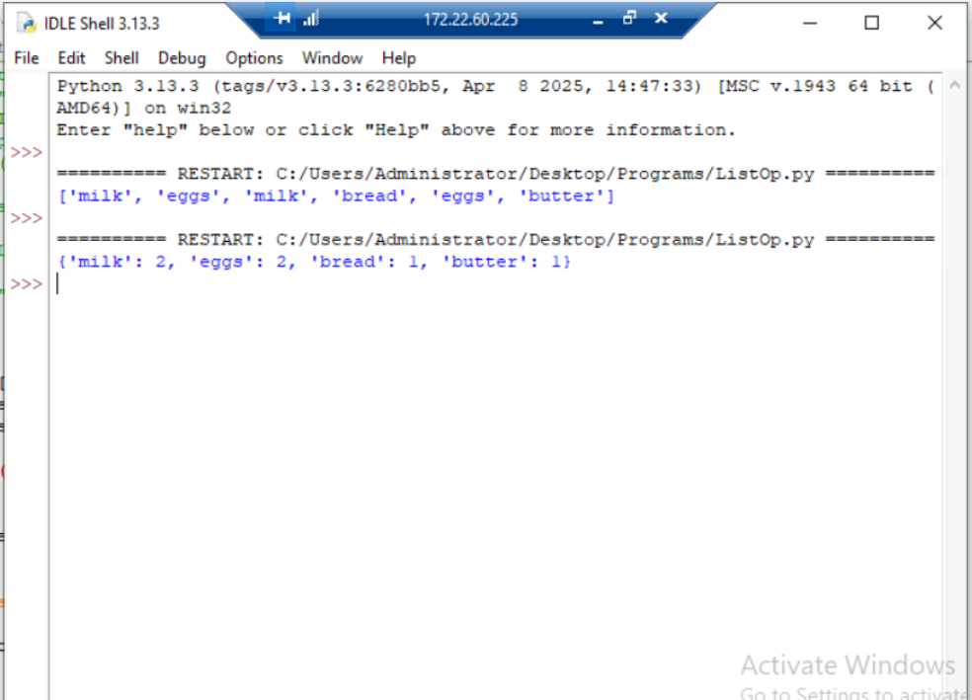

- Program to display unique items present in the list, Sort the list and reverse the list
